Day -1 : Introduction to Network Protocols

1. Wireshark Traffic Capture :
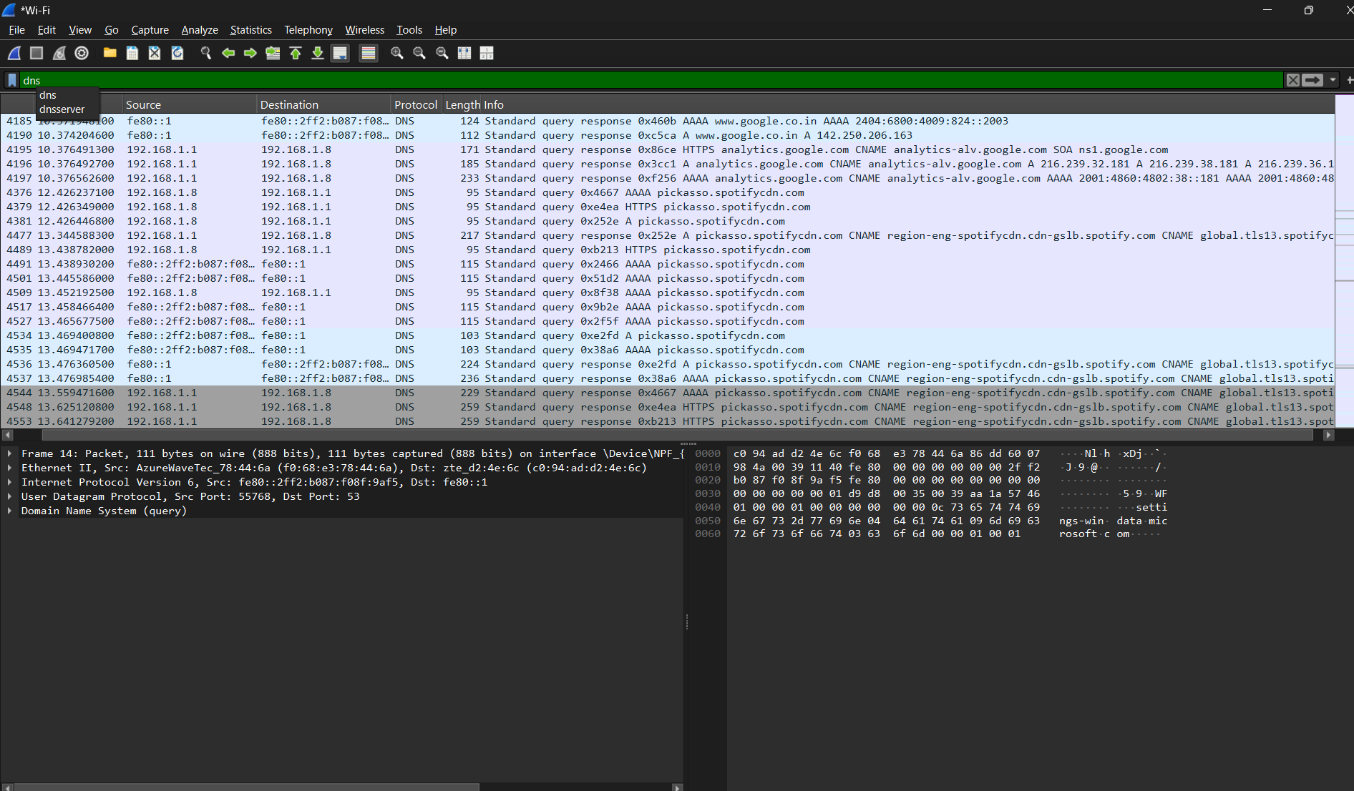

Locating HTTPS Packets:

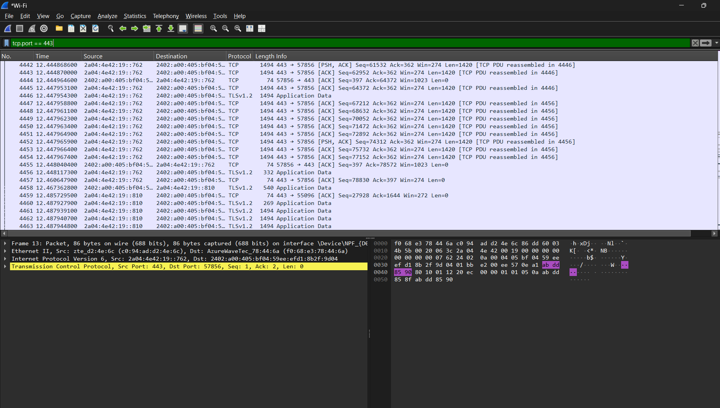
2. nslookup for www.flipkart.com :

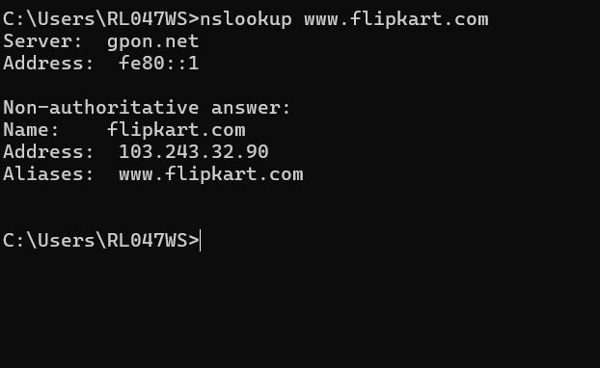
3. Differences Between HTTP and HTTPS :
Feature | HTTP (Hypertext Transfer Protocol) | HTTPS (HTTP Secure)
Security & Encryption | Transmits data in plain text without encryption. | Encrypts all traffic using TLS/SSL encryption protocols.
Default Port | Operates over TCP port 80. | Operates over TCP port 443.
Authentication | Does not verify server identity; vulnerable to man-in-the-middle attacks. | Uses SSL/TLS Digital Certificates to authenticate server identity.

4. DNS Query Sequence Observation :
- Open Wireshark, select your active interface, and type dns in the filter bar.
- Open a web browser and visit a site you haven't accessed recently (e.g., www.wikipedia.org).
- Stop the capture in Wireshark once the page loads.
Observed Sequence of Packets
- Standard Query (Request):
  - Direction: Sent from your computer's local IP address to your configured DNS server IP (e.g., 192.168.1.1 or 8.8.8.8).
  - Info Field: Standard query 0x1a2b A www.wikipedia.org
  - Meaning: Your computer asks the local DNS server, "What is the IPv4 address (A record) for www.wikipedia.org?"
- Standard Query Response (Reply):
  - Direction: Sent from the DNS server back to your computer's local IP address.
  - Info Field: Standard query response 0x1a2b A www.wikipedia.org A 185.15.59.224
  - Meaning: The DNS server responds, "The IPv4 address for www.wikipedia.org is 185.15.59.224." Once received, your browser immediately initiates a TCP handshake with that IP to fetch the page content.
5. Real-World Scenario: DHCP (Dynamic Host Configuration Protocol) :

Chosen Protocol: DHCP
Scenario: Imagine you walk into a coffee shop and turn on your phone's Wi-Fi to connect to the cafe's public network.
Before your phone can load Instagram, play a video, or send a message, it needs a valid local network address. This is where DHCP works automatically behind the scenes:
- Requesting an Address: As soon as your phone joins the Wi-Fi, it broadcasts a general message saying, "Hello! I just joined this network. Can someone give me an IP address so I can connect to the internet?"
- Assigning the Address: The cafe's Wi-Fi router running a DHCP server hears the request. It picks an unused IP address (for example, 192.168.1.45) from its available pool and assigns it to your phone for a temporary period (a "lease").
- Connection Established: Your phone receives this IP address, along with the gateway address and DNS server details.
Without DHCP, you would have to ask the barista for manual IP settings and configure network parameters by hand every time you visited a new Wi-Fi network. DHCP makes connecting to any network seamless and automatic.

